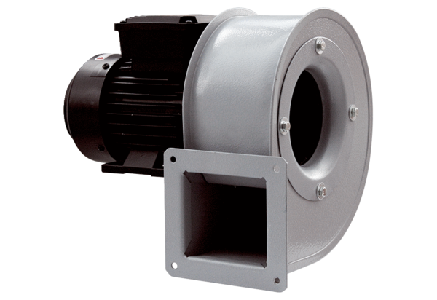Centrifugal blower GRM HT 16/2Packing unit: 1 pieceRange: C
Article number: 0073.0282Manufacturer: MAICO

