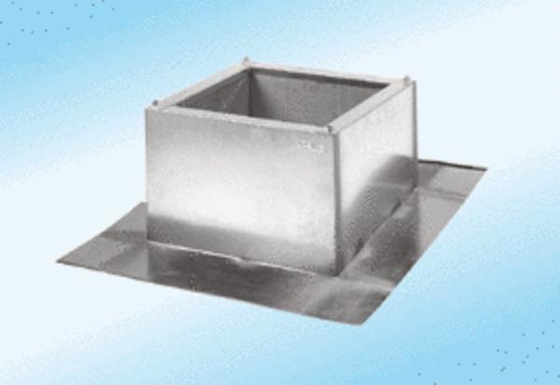Roof socket for corrugated and trapezoidal roofs SOWT 63Packing unit: 1 pieceRange:
Article number: 0093.0990ALTManufacturer: MAICO

