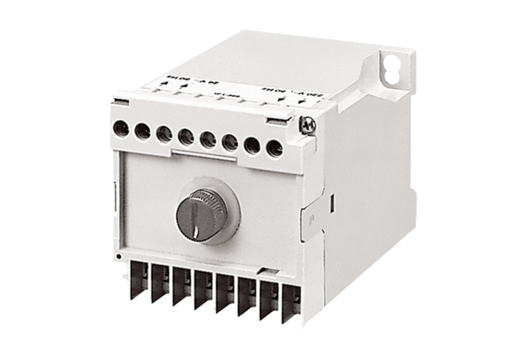Safety isolating transformer TRE 50Packing unit: 1 pieceRange: A
Article number: 0157.0385Manufacturer: MAICO

