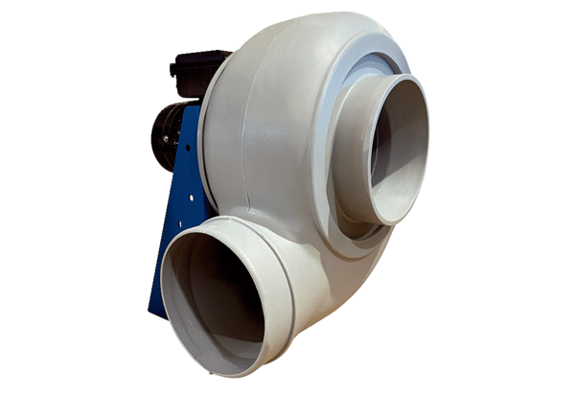Centrifugal blower GRK R 25/4 DPacking unit: 1 pieceRange: C
Article number: 0073.0515Manufacturer: MAICO

