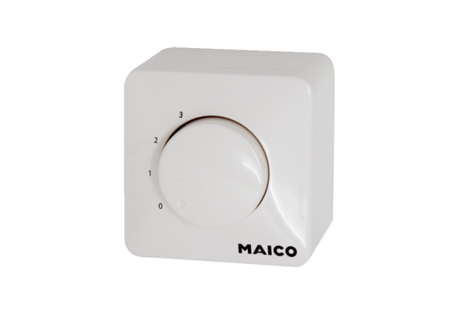Potentiometer ST EC 3Packing unit: 1 pieceRange: E
Article number: 0157.0111Manufacturer: MAICO

