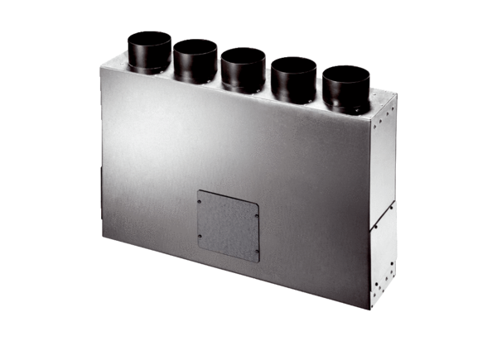Air distributor box made of sheet metal, 5-way MF-BV90-125-5Packing unit: 1 pieceRange: K
Article number: 0018.0608Manufacturer: MAICO

