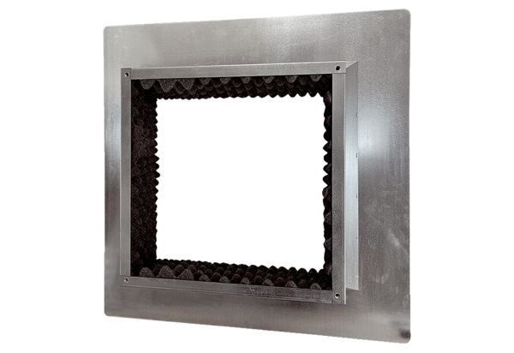Roof socket insulated, for flat roofs SOFI 40-45Packing unit: 1 pieceRange: C
Article number: 0073.0049Manufacturer: MAICO

