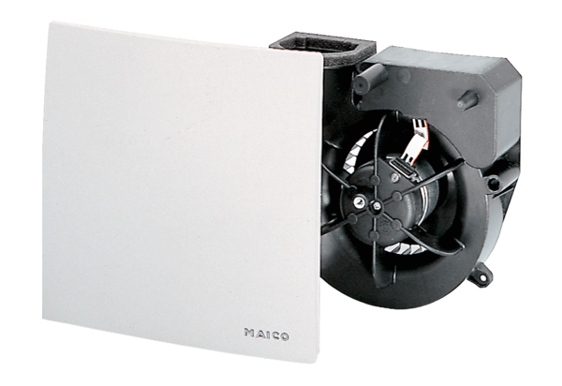Fan insert ER 60 GVZC ECPacking unit: 1 pieceRange: B
Article number: 0084.0116Manufacturer: MAICO

