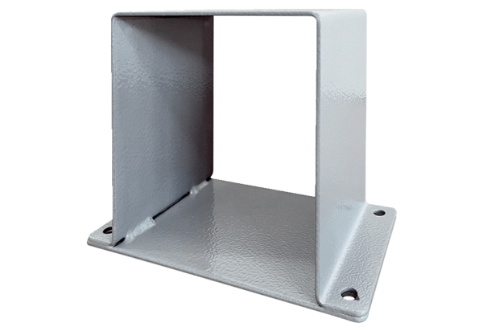Motor base MSI 10Packing unit: 1 pieceRange: C
Article number: 0073.0293Manufacturer: MAICO

