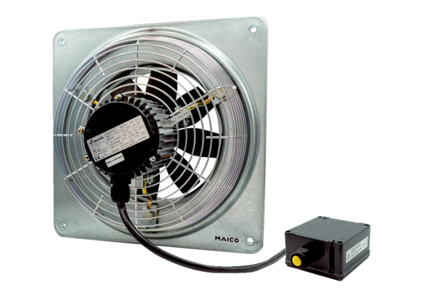Axial wall fan EZQ 20/4 E Ex tPacking unit: 1 pieceRange: C
Article number: 0083.0217Manufacturer: MAICO

