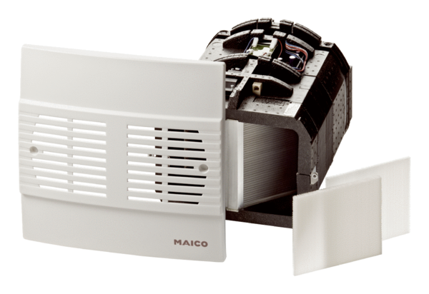Final assembly kit WRG 35-SEPacking unit: 1 pieceRange: K
Article number: 0082.0233Manufacturer: MAICO

