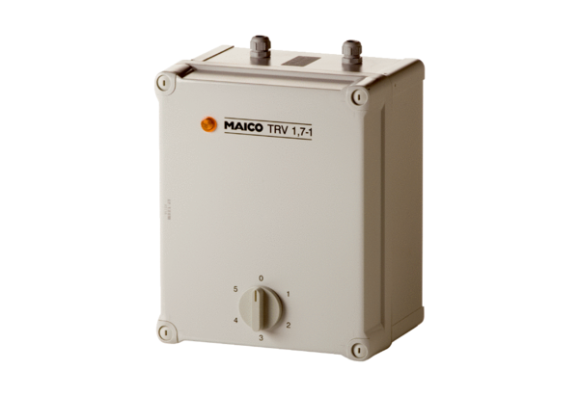5-step transformer TRV 2,5-1Packing unit: 1 pieceRange: C
Article number: 0157.0534Manufacturer: MAICO

