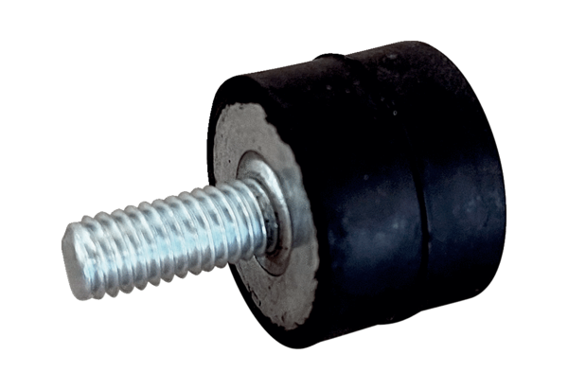Vibration damper GPI 46-65Packing unit: 1 pieceRange: C
Article number: 0073.0275Manufacturer: MAICO

