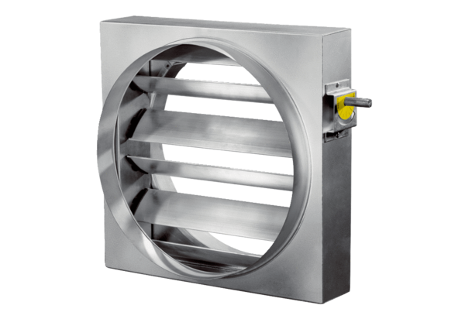Control shutter JRE 30Packing unit: 1 pieceRange: C
Article number: 0151.0391Manufacturer: MAICO

