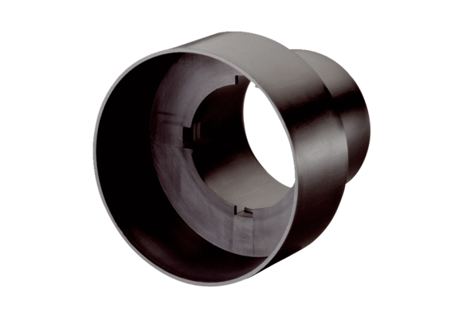Valve adaptor MF-A90Packing unit: 1 pieceRange: K
Article number: 0059.0963Manufacturer: MAICO

