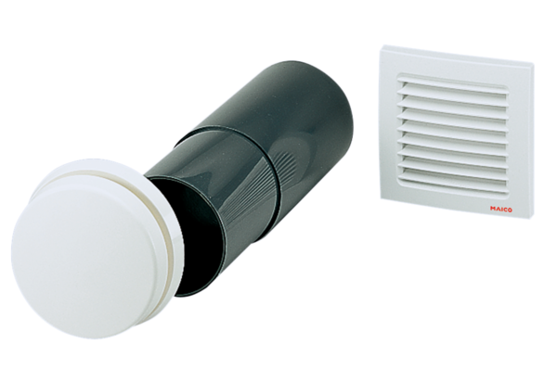Supply air element ZE 10 TPacking unit: 1 pieceRange: K
Article number: 0152.0048Manufacturer: MAICO

