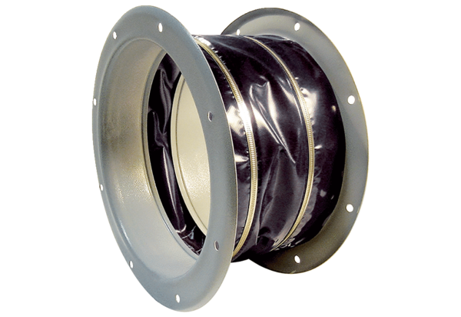Flexible coupling ELI 63 ExPacking unit: 1 pieceRange: C
Article number: 0073.0578Manufacturer: MAICO

