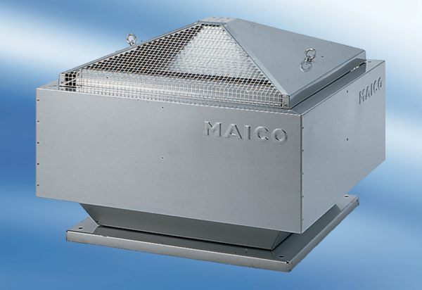Centrifugal roof fan DRD 63/6Packing unit: 1 pieceRange: C
Article number: 0087.0118Manufacturer: MAICO

