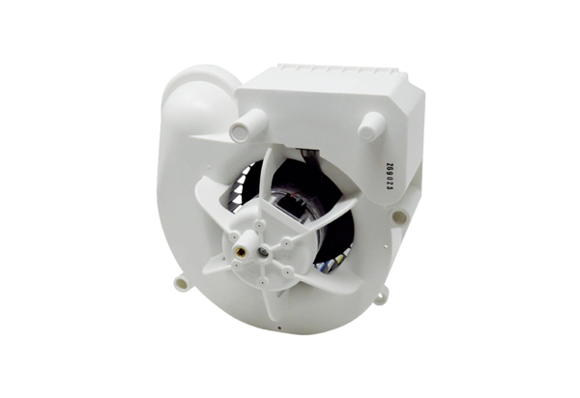Fan insert VE ER-APB 60Range: B
Article number: E084.0156.0000Manufacturer: MAICO

