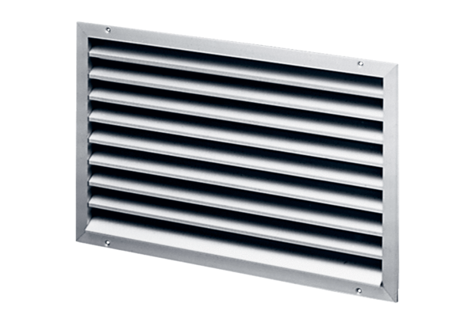External grille LAP 28Packing unit: 1 pieceRange: D
Article number: 0151.0252Manufacturer: MAICO

