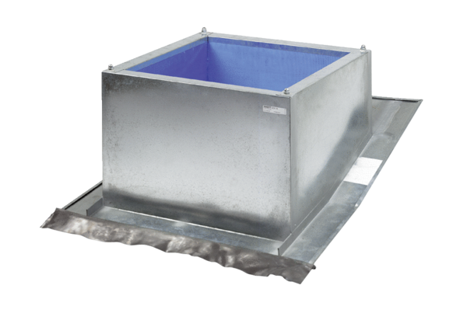Roof socket for pitched roofs SDS 18Packing unit: 1 pieceRange: C
Article number: 0093.1028Manufacturer: MAICO

