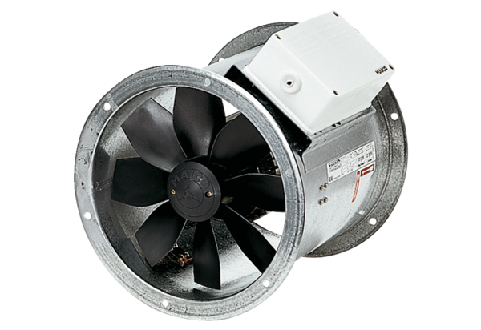Axial duct fan DZR 35/84 BPacking unit: 1 pieceRange: C
Article number: 0086.0045Manufacturer: MAICO

