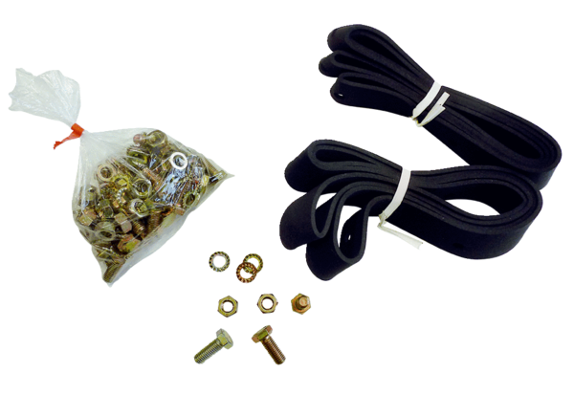Mounting and sealing material BD 25Packing unit: 1 pieceRange: C
Article number: 0092.0133Manufacturer: MAICO

