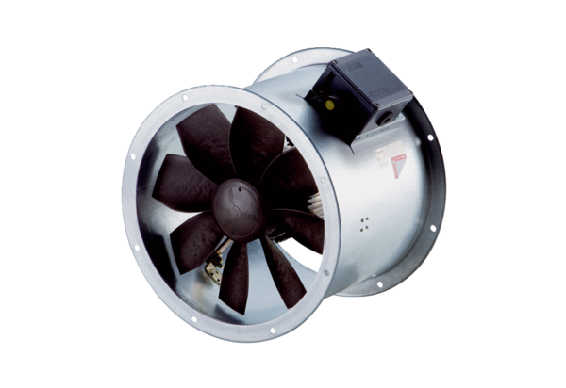Axial duct fan DZR 35/2 B Ex ePacking unit: 1 pieceRange: C
Article number: 0086.0708Manufacturer: MAICO

