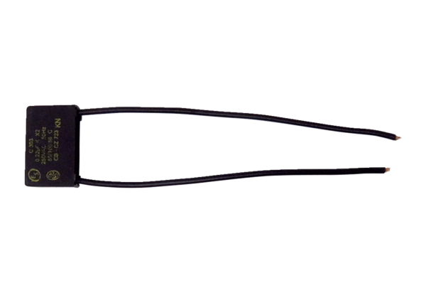Capacitor KS ECA ERRange: A
Article number: E157.0116.0000Manufacturer: MAICO

