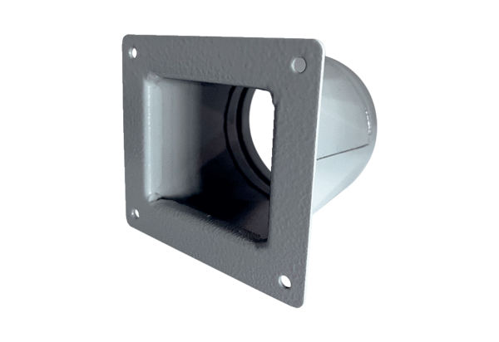Transition adapter URRI 12Packing unit: 1 pieceRange: C
Article number: 0073.0298Manufacturer: MAICO

