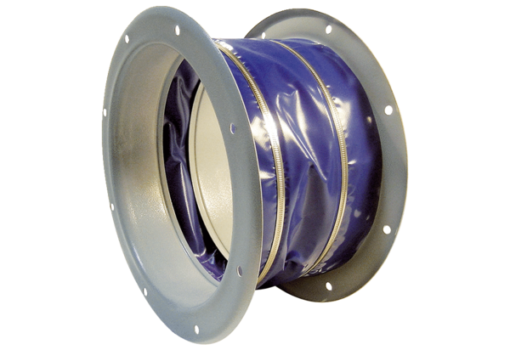Flexible coupling ELI 63Packing unit: 1 pieceRange: C
Article number: 0073.0218Manufacturer: MAICO

