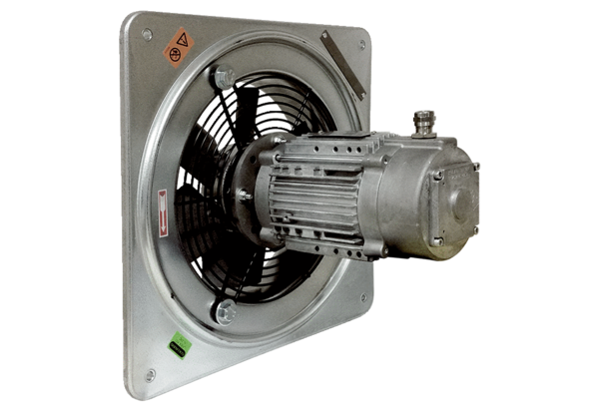Axial wall fan DAQ 63/6 ExPacking unit: 1 pieceRange: C
Article number: 0073.0335Manufacturer: MAICO

