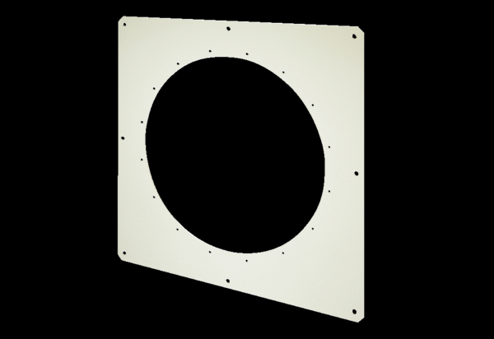Square wall plate QW 125Packing unit: 1 pieceRange: C
Article number: 0053.0018Manufacturer: MAICO

