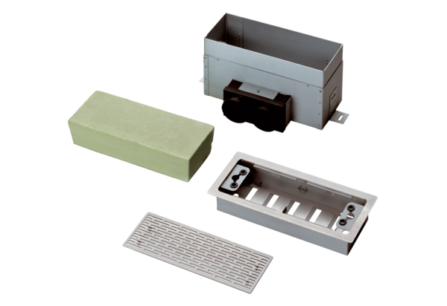Floor / wall outlet MF-FBWA 75Packing unit: 1 pieceRange: K
Article number: 0152.0066Manufacturer: MAICO

