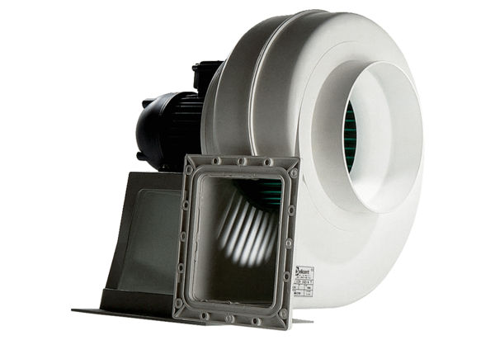Centrifugal blower GRK 12/2 EPacking unit: 1 pieceRange: C
Article number: 0073.0302Manufacturer: MAICO

