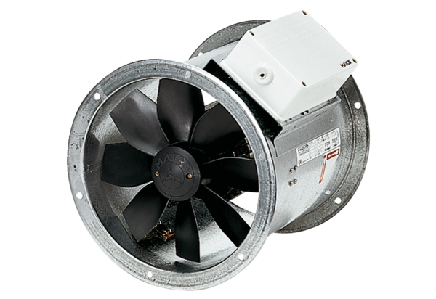Axial duct fan DZR 40/84 BPacking unit: 1 pieceRange: C
Article number: 0086.0048Manufacturer: MAICO

