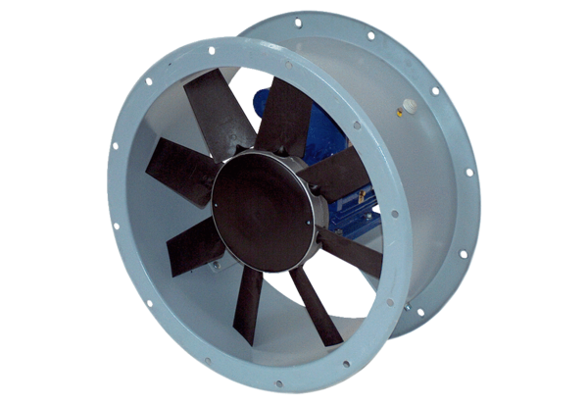Axial duct fan DAR 80/4 3-2Packing unit: 1 pieceRange: C
Article number: 0073.0139Manufacturer: MAICO

