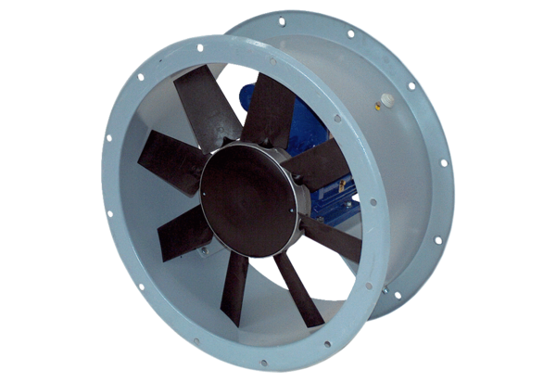Axial duct fan DAR 71/6 0,75Packing unit: 1 pieceRange: C
Article number: 0073.0134Manufacturer: MAICO

