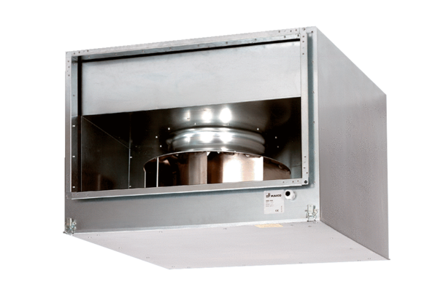Sound-insulated channel fan DSK 31/4Packing unit: 1 pieceRange: D
Article number: 0086.0645Manufacturer: MAICO

