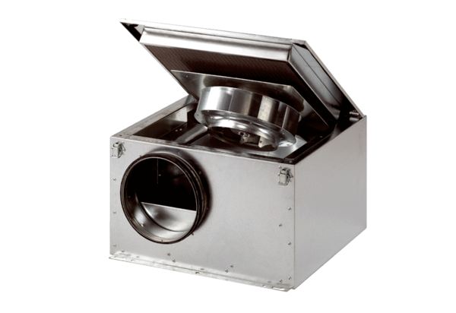Sound-insulated ventilation box ESR 20 SPacking unit: 1 pieceRange: C
Article number: 0080.0229Manufacturer: MAICO

