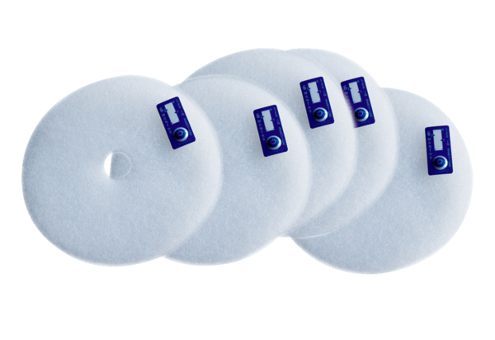Air filter, replacement ZF EC+ bulk containerPacking unit: 100 piecesRange: B
Article number: 0093.0611Manufacturer: MAICO

