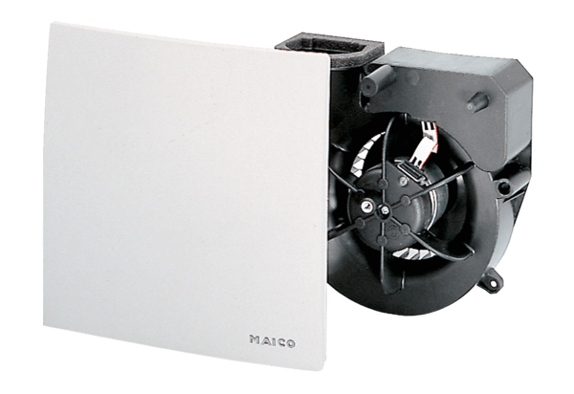Fan insert ER 100 VZPacking unit: 1 pieceRange: B
Article number: 0084.0131Manufacturer: MAICO

