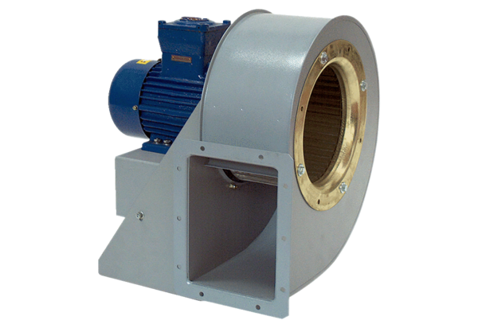Centrifugal blower GRM HD 35/4-1 ExPacking unit: 1 pieceRange: C
Article number: 0073.0409Manufacturer: MAICO

