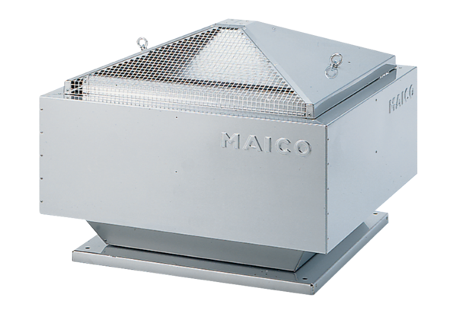Centrifugal roof fan MDR 35 ECPacking unit: 1 pieceRange: E
Article number: 0087.0028Manufacturer: MAICO

