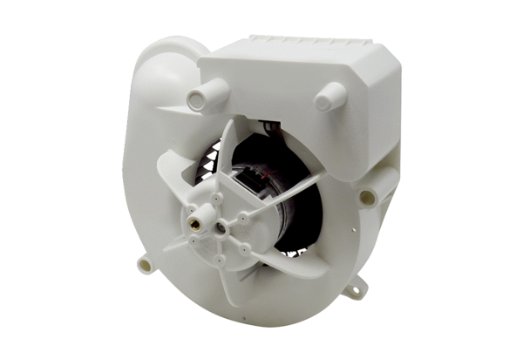Fan insert VE ER-AP 60 GRange: B
Article number: E084.0153.0000Manufacturer: MAICO

