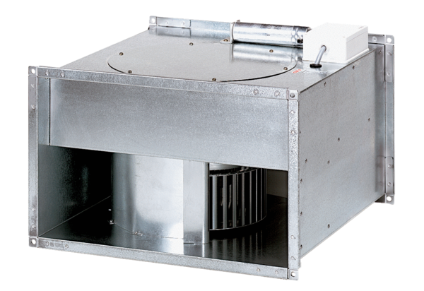Channel fan EPK 28/4 BPacking unit: 1 pieceRange: D
Article number: 0086.0655Manufacturer: MAICO

