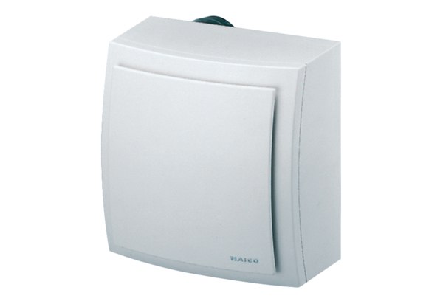Surface-mounted fan ER-AP 60 HPacking unit: 1 pieceRange: B
Article number: 0084.0154Manufacturer: MAICO

