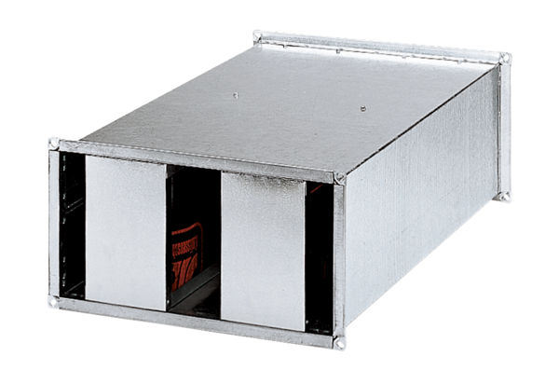Channel sound absorber KSP 22/27Packing unit: 1 pieceRange: D
Article number: 0092.0330Manufacturer: MAICO

