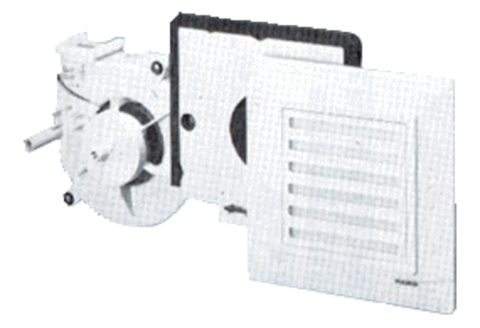Fan insert ER 17/60 VZPacking unit: 1 pieceRange:
Article number: 0080.0736Manufacturer: MAICO

