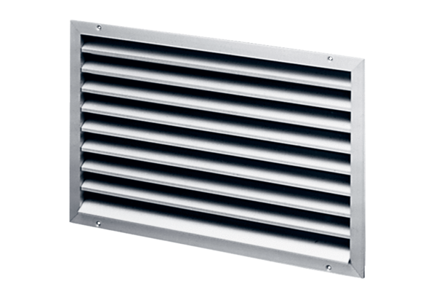External grille LAP 56Packing unit: 1 pieceRange: D
Article number: 0151.0313Manufacturer: MAICO

