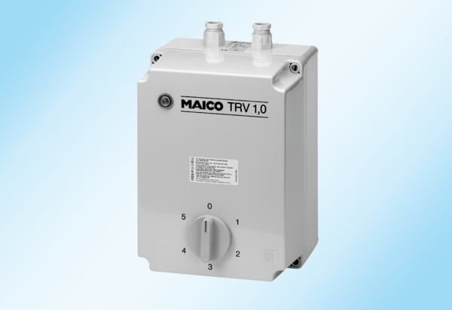5-step transformer TRV 2,5Packing unit: 1 pieceRange: C
Article number: 0157.0717Manufacturer: MAICO

