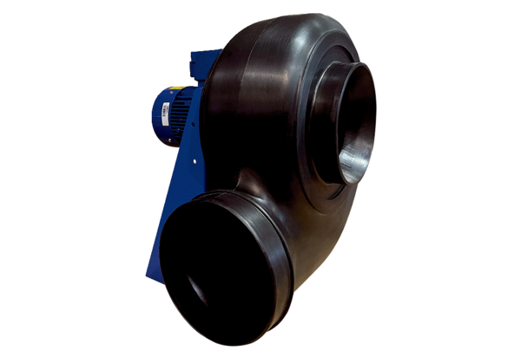Centrifugal blower GRK R 35/2 D ExPacking unit: 1 pieceRange: C
Article number: 0073.0449Manufacturer: MAICO

