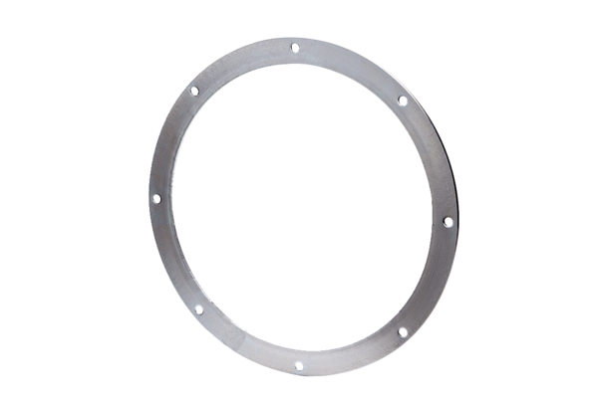Counter flange GF 40Packing unit: 1 pieceRange: C
Article number: 0056.0006Manufacturer: MAICO

