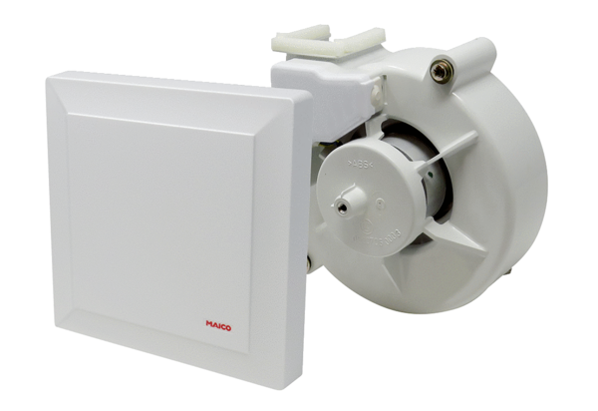Fan insert with cover VEA ER 17/60-2 VZ<data>
<p class="FT">Range:</p>
</data>
B
<data>
<p class="FT">Article number:</p>
</data>
E080.0783.0000<data>
<p class="FT">Manufacturer:</p>
</data>
MAICO

